**ASSIGNMENT – 02**

Create a New Facebook business page and post one social media poster your brand

NAME- Saravanan S

NM ID- : 71400EFD6E6F9B6898F4EC9B25D9EB87

LINK -[https://www.facebook.com/profile.php?id=61550694203958&mibextid=ZbWKwL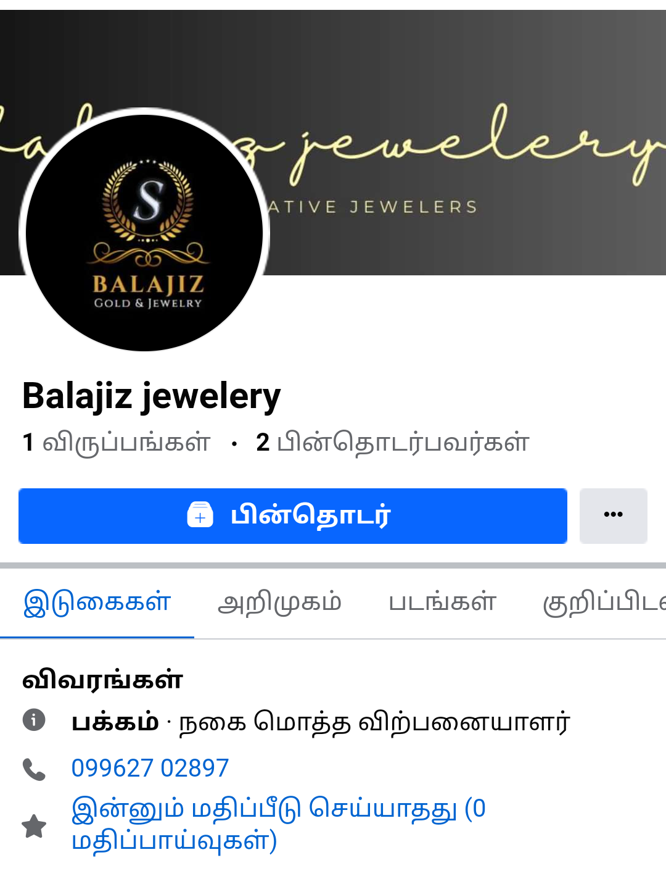](https://www.facebook.com/profile.php?id=61550694203958&mibextid=ZbWKwL*)

